2253 CFGS Web Application Development

Module 2 – Data Bases

UF2 – SQL Language: DDL and DML
NF4 – Data Manipulation Language
ACTIVITY

ACTIVITY DONE BY  Aaron Andal | 1DAW

Using select in DDL and DML sentences

Description

1. Implement next SQL DML statements in HOSPITAL database.

The Entity-Relationship:

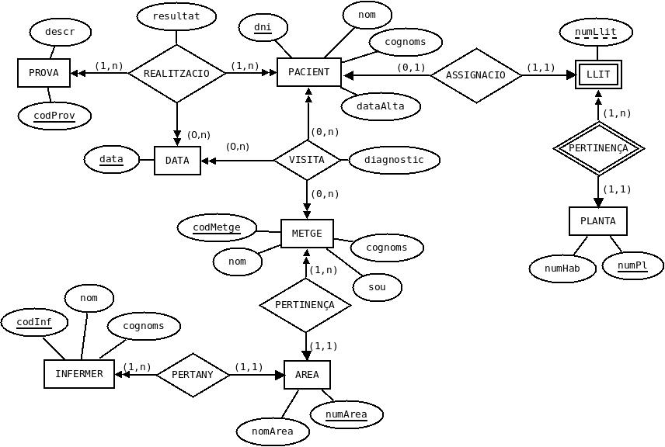
And the relational model:

AREA (numArea, nomArea)

PROVA (codProv, descr)

PLANTA (numPl, numHab)

LLIT (numPl, numLlit)
ON {numPl} REFERENCIA PLANTA

PACIENT (dni, nom, cognoms, dataAlta, numP, numL)
ON {numP,numL} REFERENCIA LLIT (numPl,numLlit)

METGE (codMetge, nom, cognoms, sou, numArea)
ON {numArea} REFERENCIA AREA

INFERMER (codInf, nom, cognoms, numArea)
ON {numArea} REFERENCIA AREA

VISITA (dniPac, codMetge, data, diagnostic)
ON {dniPac} REFERENCIA PACIENT(dni)
i {codMetge} REFERENCIA METGE

REALITZACIO (codProv, dniPac, data, resultat)
ON {codProv} REFERENCIA PROVA
i {dniPac} REFERENCIA PACIENT(dni)

1. Inert the patient ('22222226D', 'Joan', 'Gimeno', '2014-04-18', 2, 11).

INSERT INTO PACIENT VALUES ('22222226D' , 'Joan', 'Gimeno', '2014-04-18', 2, 11);
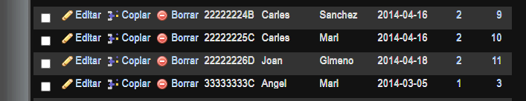

2. Insert the patient (('22222227E', 'Carla', 'Ros', '2014-04-18') no indicating the bed assigned to him. Write two sentences.

INSERT INTO PACIENT VALUES ('22222227E', 'Carla', 'Ros', '2014-04-18', NULL, NULL);
INSERT INTO PACIENT (PACIENT.dni, PACIENT.nom, PACIENT.cognoms, PACIENT.dataAlta) VALUES ('22222227E', 'Carla', 'Ros', '2014-04-18')
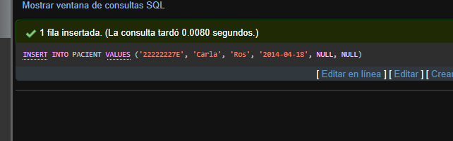

3. Insert a new patient ('22222228F', 'Rosa', 'Sala') taking the date from the system.

INSERT INTO PACIENT (PACIENT.dni, PACIENT.nom, PACIENT.cognoms, PACIENT.dataAlta) VALUES ('22222228F', 'Rosa', 'Sala', SYSDATE());

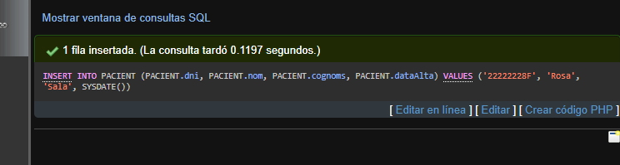
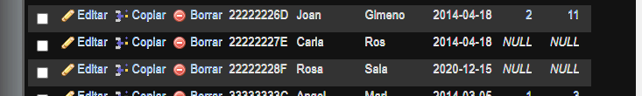

4. Insert a new doctor (7,'Irene','Villegas', 65000.0) in Neurologia. The area code must be read from the DB.

INSERT INTO METGE VALUES (7,'Irene','Villegas', 65000.0, (SELECT numArea FROM AREA WHERE nomArea LIKE 'Neurologia'));
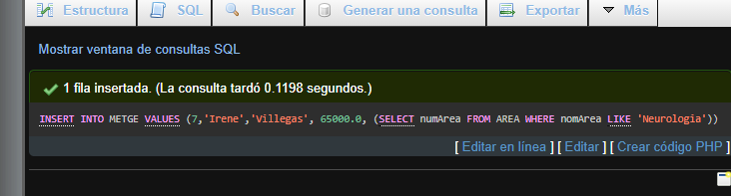

5. Add 5000€ to the salary of all the doctors.

UPDATE METGE SET METGE.sou = METGE.sou+5000;
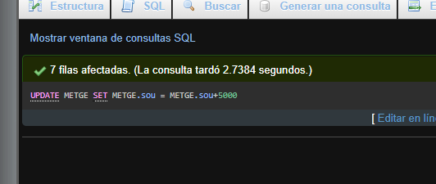

6. Increment in 10% the salary of all the doctors who work at area 3.

UPDATE METGE SET METGE.sou = METGE.sou+(METGE.sou*0.10) WHERE METGE.numArea = 3;
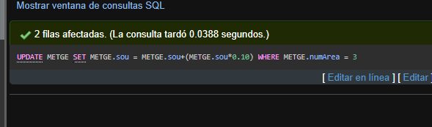

7. Update names and surnames of all the doctors to capital letters.

UPDATE METGE SET METGE.nom = UPPER(METGE.nom);
UPDATE METGE SET METGE.cognoms = UPPER(METGE.cognoms);
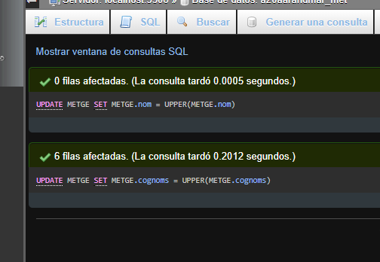
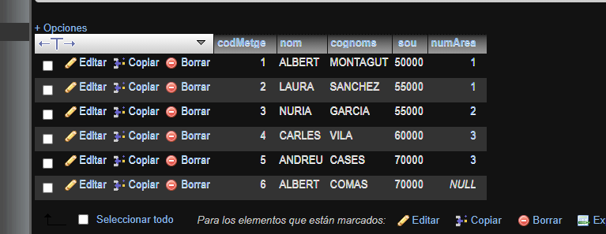

8. Increment 5% the salary of all the doctors who work in Neurologia.

UPDATE METGE SET METGE.sou = METGE.sou+(METGE.sou*0.05) WHERE (SELECT AREA.numArea FROM AREA WHERE AREA.nomArea = 'Neurologia');
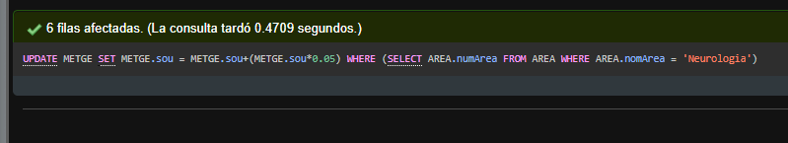

9. The doctor Laura Sanchez change area to Neurologia.

UPDATE METGE SET METGE.numArea = (SELECT AREA.numArea FROM AREA WHERE AREA.nomArea = 'Neurologia') WHERE METGE.nom = 'Laura';

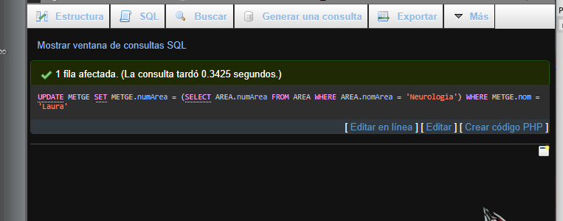

10. Add a new column to PLANTA table to store the number of patients in every floor. Set its value consulting to the DB the number of patients in every floor

ALTER TABLE PLANTA ADD COLUMN numPacientsPlanta INT(11);
UPDATE PLANTA SET PLANTA.numPacientsPlanta = (SELECT COUNT(PACIENT.nom) FROM PACIENT GROUP BY PACIENT.numP HAVING PACIENT.numP = 1) WHERE PLANTA.numPacientsPlanta IS NULL;
UPDATE PLANTA SET PLANTA.numPacientsPlanta = (SELECT COUNT(PACIENT.nom) FROM PACIENT GROUP BY PACIENT.numP HAVING PACIENT.numP = 2) WHERE PLANTA.numPacientsPlanta IS NULL;
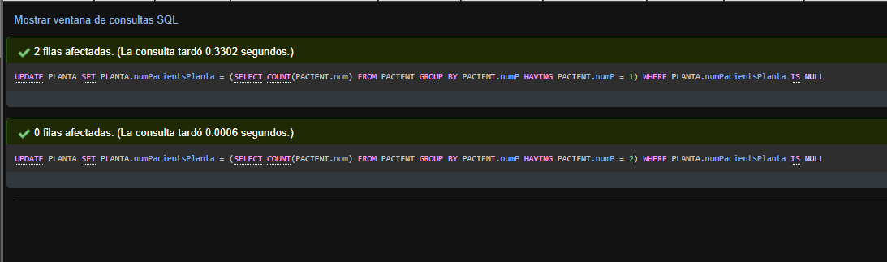
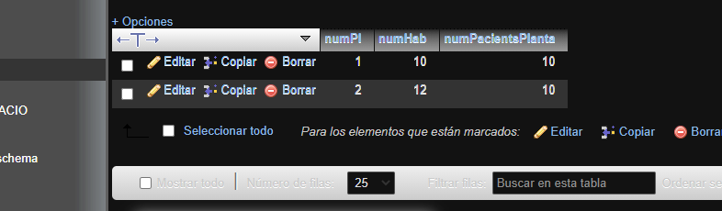

11.Remove all the visits.

DELETE FROM VISITA
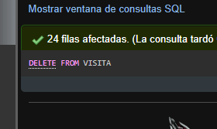

12. Remove all the registers in REALITZACIO table wich datra belongs to April of 2014.

DELETE FROM REALITZACIO WHERE REALITZACIO.data = '2014-04%';

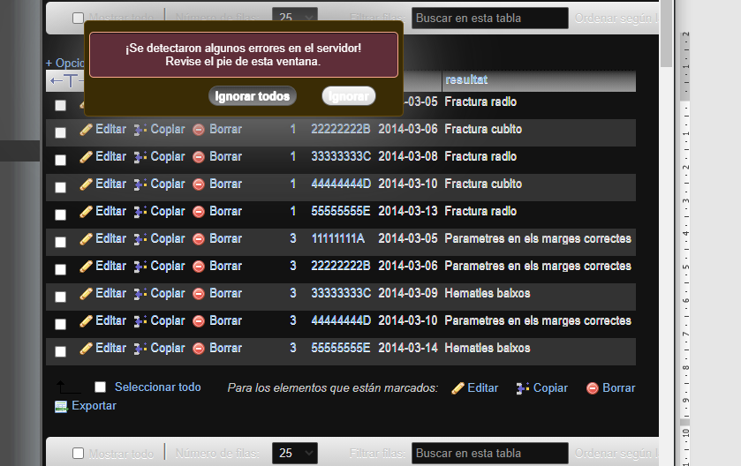

13. Create a view for every floor (PLANTA1, PLANTA2) with all the information of the patients who are in this floor (without number of the floor) with check option.

CREATE VIEW PLANTA1 AS SELECT * FROM PACIENT WHERE PACIENT.numP = 1;
CREATE VIEW PLANTA2 AS SELECT * FROM PACIENT WHERE PACIENT.numP = 2;

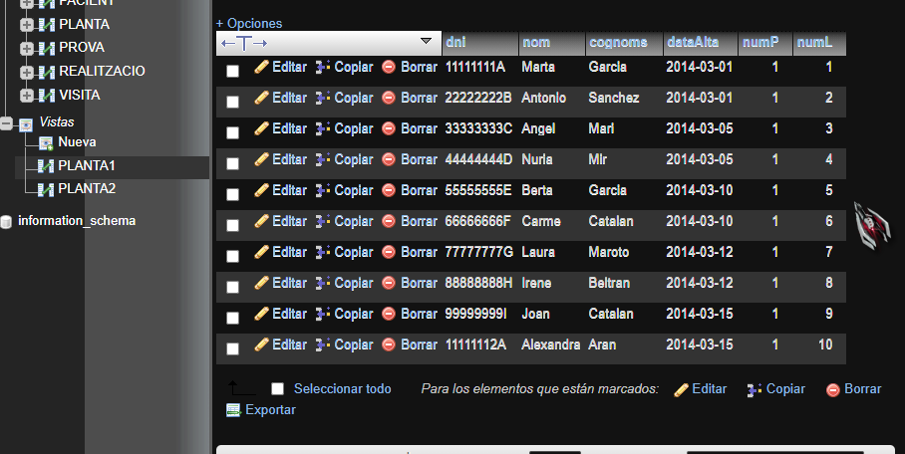

14. Insert a patient in the table PACIENT and test what happens in the view PLANTA1.

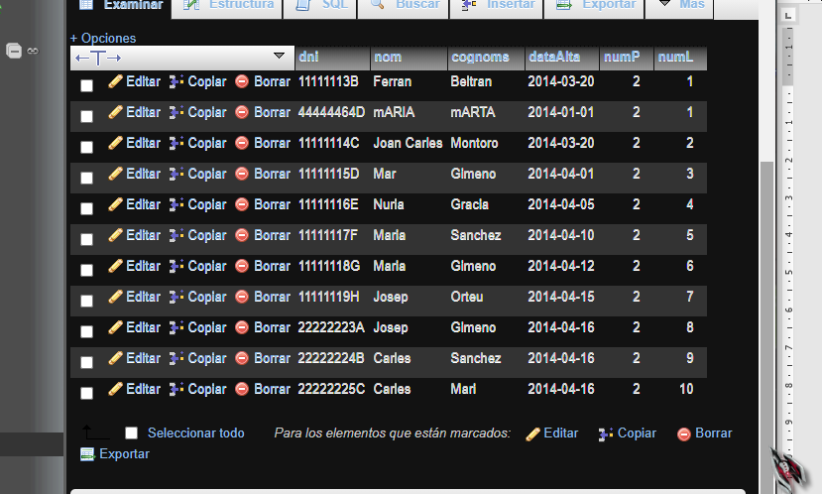
SE HA AÑADIDO CORRECTAMENTE

15. Insert a patient in view PLANTA1 and test what happens in table PACIENT.

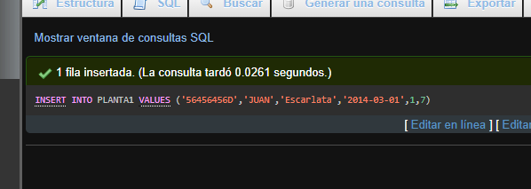

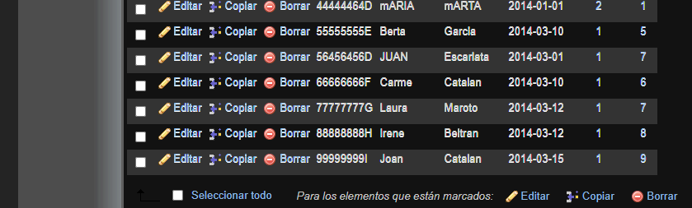

Se añade tambien

16. Create a view DOCTORS_IN_AREA with two columns: numArea and numDoctors where numDoctors stores the number of doctors in the area.

CREATE VIEW DOCTORS_IN_AREA (NUMAREA, NUMDOC) AS SELECT METGE.numArea, COUNT(METGE.nom) FROM METGE GROUP BY METGE.numArea;
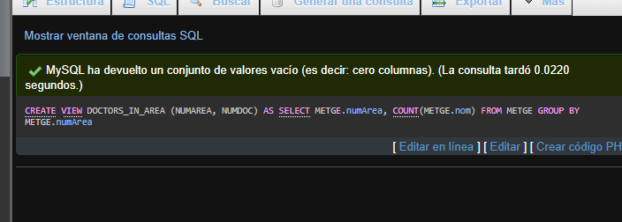
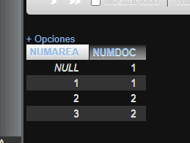

17. Insert a new doctor in METGE and test what happens in DOCTORS_IN_AREA view

INSERT INTO METGE VALUES (7, 'ARUBATO', 'HOWLO', 57845,3);
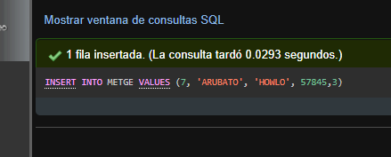
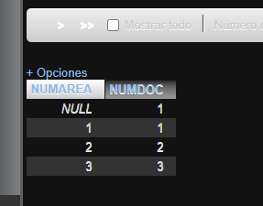
Se actualiza

